|  |  |  |  |
| --- | --- | --- | --- |
| **Name of Student: Pushkar Sane** | | | |
| **Roll Number: 45** | | **Lab Assignment Number: 3** | |
| **Title of Lab Assignment: Create an application to demonstrate Node.js Event Emitter.** | | | |
| **DOP: 25-09-2023** | | **DOS: 26-09-2023** | |
| **CO Mapped:**  **CO1** | **PO Mapped:**  **PO3, PO5, PSO1, PSO2** | **Faculty Signature:** | **Marks:** |

**Practical No. 3**

**Aim:**

1. Create an application to demonstrate various Node.js Events in the event emitter class.
2. Create functions to sort, reverse and search for an element in an array. Register and trigger these functions using events.

**Description:**

**Understanding the Node.js EventEmitter Module**

* **Purpose of EventEmitter:**

The EventEmitter module is a fundamental component of Node.js, designed to facilitate the implementation of event-driven programming. Node.js is known for its asynchronous, non-blocking I/O model, and EventEmitter plays a pivotal role in building scalable and responsive applications by allowing different parts of the code to communicate efficiently through events.

* **Key Components:**

1. EventEmitter Class:
2. The core of the EventEmitter module is the EventEmitter class. It provides methods for emitting events and registering event listeners.
3. Developers can create instances of this class to manage custom events within their applications.
4. Event:
   1. An event is a signal or notification that something specific has happened. It is identified by a unique name or identifier.
   2. Events can be emitted (triggered) by an EventEmitter instance when a particular action or condition occurs.
5. Event Listener:
   1. An event listener is a function that is registered to respond to a specific event when it is emitted.
   2. Event listeners are responsible for handling events by executing custom code in response to the event.

* **Example Usage:**

Let's illustrate the usage of the EventEmitter module with a simple example:

const EventEmitter = require('events');

const myEmitter = new EventEmitter(); // Register an event listener

myEmitter.on('greet', (name) => {

console.log(`Hello, ${name}!`);

}); // Emit the 'greet' event

myEmitter.emit('greet', 'John');

In this example, we:

1. Import the `events` module and create an instance of `EventEmitter`.
2. Register an event listener for the 'greet' event.
3. Emit the 'greet' event with a 'name' argument, triggering the event listener to execute and print a greeting.
4. This simple example demonstrates the EventEmitter's role in event-driven programming, where events are emitted and listeners respond to them.

* **Practical Applications**

1. HTTP Servers: EventEmitter is extensively used in building Node.js HTTP servers. HTTP requests, such as 'request' and 'response' events, are handled using EventEmitter to make servers highly responsive.
2. File I/O: Reading and writing files asynchronously often involve EventEmitter. Events like 'data' and 'end' are emitted during file streams to handle data chunks and stream completion.
3. Custom Applications: Developers can create custom events and listeners for various scenarios within their applications. For instance, handling user interactions, real-time updates, or custom triggers.
4. Create an application to demonstrate various Node.js Events in the event emitter class.

**Code:**

const events = require('events');

const someEventHandler = x => console.log('event', x, 'occurred');

const emitter = new events.EventEmitter();

console.log("Add event handler for someEvent by calling emitter.on('someEvent', someEventHandler)");

emitter.on('someEvent', someEventHandler);

console.log("\nEmitter eventNames() is =", emitter.eventNames());

console.log('\nEmit someEvent with someValue by calling emitter.emit("someEvent", "someValue")');

emitter.emit('someEvent', 'someValue');

console.log("\nEmitter listenerCount('someEvent') is =",

emitter.listenerCount('someEvent'));

console.log("\nRemove event handler by calling emitter.removeListener('someEvent', someEventHandler)");

emitter.removeListener('someEvent', someEventHandler);

console.log("\nEmitter listenerCount('someEvent') after removing event handler is =",

emitter.listenerCount('someEvent'));

**Output:**

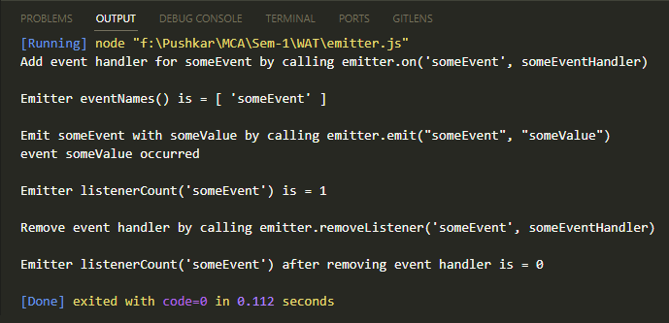

1. Create functions to sort, reverse and search for an element in an array. Register and trigger these functions using events.

**Code**

**array_operation.js**

const EventEmitter = require('events');

class ArrayOperations extends EventEmitter {

constructor() {

super();

}

// Function to sort an array

sortArray(arr) {

const sortedArray = arr.slice().sort((a, b) => a - b);

this.emit('sorted', sortedArray);

}

// Function to reverse an array

reverseArray(arr) {

const reversedArray = arr.slice().reverse();

this.emit('reversed', reversedArray);

}

// Function to search for an element in an array

searchArray(arr, target) {

const index = arr.indexOf(target);

this.emit('searched', { target, index });

}

}

module.exports = ArrayOperations;

**array_main.js**

const ArrayOperations = require('./arrayOperations');

const arrayOps = new ArrayOperations();

// Register event listeners

arrayOps.on('sorted', (sortedArray) => {

console.log('Sorted Array:', sortedArray);

});

arrayOps.on('reversed', (reversedArray) => {

console.log('Reversed Array:', reversedArray);

});

arrayOps.on('searched', ({ target, index }) => {

if (index !== -1) {

console.log(`${target} found at index ${index}`);

} else {

console.log(`${target} not found in the array`);

}

});

// Sample array

const myArray = [5, 2, 8, 1, 9, 4, 3, 7, 6];

// Trigger the functions using events

arrayOps.sortArray(myArray);

arrayOps.reverseArray(myArray);

arrayOps.searchArray(myArray, 4);

arrayOps.searchArray(myArray, 10);

**Output:**

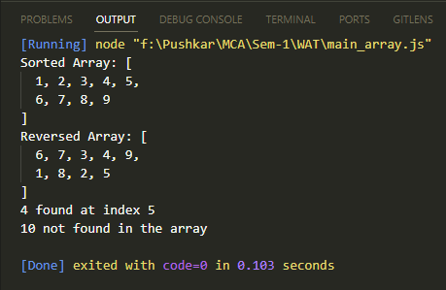

**Conclusion:**

In conclusion, the Node.js EventEmitter module is a cornerstone of Node.js development, enabling event-driven programming in both core modules and custom applications. It serves as a powerful communication mechanism, allowing different parts of an application to interact efficiently by emitting and responding to events.

The EventEmitter module is vital for building scalable and responsive applications that can handle numerous simultaneous events and asynchronous operations. Its use cases extend from HTTP servers and file I/O to custom application scenarios, making it a fundamental skill for Node.js developers.

By understanding and effectively utilizing EventEmitter, developers can harness the full potential of Node.js's event-driven architecture, resulting in robust, modular, and highly responsive applications that meet the demands of modern web and server development.